Oregon FIRST Robotics Grant Program
Report for 2013-2014

Background
FIRST (For Inspiration and Recognition of Science and Technology) was founded in 1989 to inspire young people's interest and participation in science and technology. Based in Manchester, NH, the not-for-profit public charity designs accessible, innovative programs that motivate young people to pursue education and career opportunities in science, technology, engineering, and math, while building self-confidence, knowledge, and life skills.
The FIRST programs are developed to inspire young people to be science and technology leaders. Their programs stretch from Kindergarten to grade 12. The Junior FIRST Lego League (Jr. FLL) and FIRST Lego League (FLL) programs use Legos and research to explore a scientific or engineering challenge. The younger teams build models using Legos while the older teams dig into the robotics capabilities. From grades 7 to 12, students can participate in the FIRST Tech Challenge (FTC) or FIRST Robotics Competition (FRC). The two programs differ in the robotics platform with FTC being a smaller and less expensive system than FRC. Both the FTC and FRC programs release an annual game that students play using their robot designs. All four of the FIRST programs utilize community mentors to help inspire and teach the students.
Oregon began participating in FIRST programs in 2001. Oregon Robotics Tournament and Outreach Program (ORTOP) started with 64 FIRST Lego League (FLL) teams. ORTOP expanded their reach to include the FIRST Tech Challenge (FTC) and Junior FIRST Lego League (Jr. FLL). There were almost 800 Oregon teams who participated in one of those programs over the last year. The FIRST Robotics Competition (FRC) program also started in Oregon in 2001 with seven teams centered on Albany, Bend, and Corvallis. The FRC program in Oregon has grown to 43 teams from as far South as Ashland and as far East as Union.
The Oregon FIRST Robotics Grant was first funded during the 2011 to 2013 biennium as part of the budget reconciliation bill. The initial fund was $150,000 that was used to support a single round of grants in the first year of the biennium. During the 2013 to 2015 biennium, that funding increased to $635,000 through the ODE budget and an additional allocation from the Legislature. This report focuses on the first round of grants funded in the 2013-2015 biennium. The total funds have been split to allow a second year of grant applications.

Distribution of Grant Awards
This map shows the locations of all Oregon FIRST Robotics Grant recipients for the 2013-2014 school year.
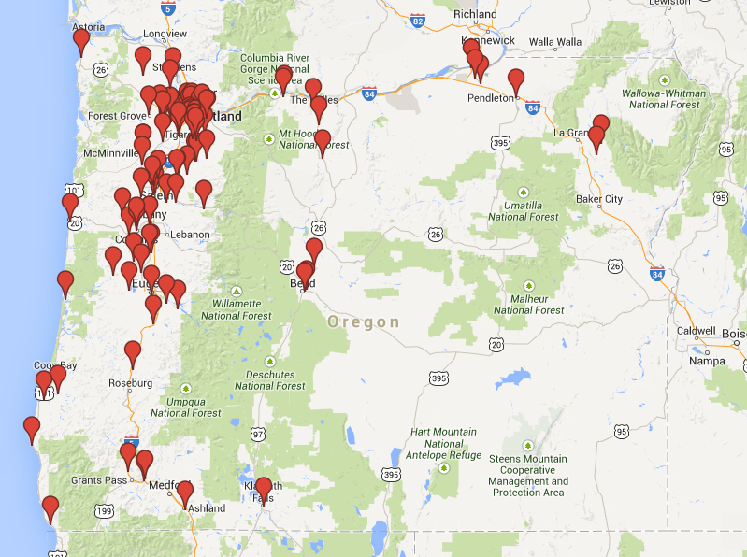
By the Numbers
Grant Awards
Total Grant Awards | $321,500.00
Total Schools Served | 105
Total Teams Funded | 193
FIRST Lego League (FLL) Teams (Elementary and Middle School) | 48
FIRST Tech Challenge (FTC) Teams (Middle and High School) | 113
FIRST Robotics Competition(FRC) Teams (High School) | 32
Number of new teams funded | 83
Percent applications funded | 85%
Percent Schools That Intend to Continue | 93%

- Approximately half of the total funds available for the biennium were awarded to schools in the 2013-2014 academic year. The remaining funds will be awarded on a competitive basis for the 2014-2015 academic year.
- The greatest growth in FIRST programs happened with FIRST Tech Challenge (FTC). FTC is a medium-priced entry point for middle schools and high schools. It also provides a technological bridge between the Lego platform in FLL and the more open-ended platform in FRC. Some schools have designed a sequence of robotics teams that progress from FLL to FTC and FRC.
- Even with the increased funds from the previous biennium, only 85% of the applications could be funded.
Student Participation
Total Students Served | 1904
Male Students | 76%
Female Students | 24%
Minority Students | 26%
Students with Disabilities | 6%
Students with Limited English Proficiency | 3%
Students in Poverty | 32%
Students new to FIRST Programs | 78%
High School Seniors Planning to Pursue Further STEM Education | 175

- The student participation statistics reflect only those in programs funded through this grant. Many of the FIRST programs are run after school hours. Some are run as a class or instructional activity during the school day.
- The grant funded teams are reaching approximately 0.5% of all eligible students in grades 4 through 12. Although the enrollment is a small percent of all students, the impact on students in the program can be significant. We estimate that 80% of high school seniors (175 students) in these FIRST programs intend to pursue further STEM education.
- The percent minority participation in grant funded FIRST programs falls below the 35% of minority students in Oregon schools. The grant awards for the 2014-2015 school year will focus more heavily on minority participation.
- The percent of girls who participate in these programs is about the same as the percent of women in STEM careers nationally. More work needs to be done to raise female participation.

Community Participation
Adult Mentors | 526
Sponsors other than this grant | 576
Financial Support other than this grant | $356,610

- These numbers and stories we have collected from FIRST teams demonstrate the positive support that local communities provide for FIRST teams. Most of the adult mentors on FIRST teams are volunteers. On average, the ratio of mentors to students is between 1:3 and 1:4. There is a great deal of research that demonstrates the impact of adult mentorship on student success.
- The financial contribution that communities make to support these teams is greater than the grant support provided. This doesn’t include the millions of dollars in support at the state and national level.
Use of Funds
Average Grant Investment per Student | $169.00
How Grant Funds Were Used
Registration | 32%
Coach Stipends | 10%
Purchased Services | 2%
Travel, Food, Lodging | 7%
FLL and FTC Kits | 15%
Materials | 21%
Equipment | 13%

- The greatest use of grant funds (47%) was for expenses related to starting a robotics program for the year. Those expenses included registration of the team and purchase of required kits. Additional materials and equipment needed to design and build a robot amounted to about 34% of grant funds. The low percentage used for coach stipends is consistent with the high level of involvement from community volunteers. Finally, travel to events consumed a relatively small percentage of the funds even though those costs can be very high for teams in many parts of the state.

Comments from the field
The grant recipients were asked to respond to six questions to provide some understanding on the impact this grant program has had on students, schools, and communities. What follows are examples of feedback received by the grant recipients.
Student Confidence and Engagement
The reports included numerous references on how the FIRST program helped build student confidence in their own abilities and engagement in school and the program. The repeated message was that students were able to connect with others who had similar interests and forge strong team bonds. These are results that are difficult to measure but can have a profound impact on student success in school.
“Students got the chance to interact with other students from other schools that have similar interests and this helped validate who they are as a person, as we are a rural school and often prior to robotics these students may feel like they are on the fringes of normal society. The students feel the power of success when you hand craft something and see it work the way you envisioned.” –Junction City High School
“Our season ended in the middle of May, and even though the weather is beautiful outside robotics students are asking ‘When do we start robotics again?’ We’ve had a fabulous season introducing this program to our students, coaches and community and are looking forward to what’s next.” –SEI Academy
“Cooperative competition is really evident and spoken about by students and mentors alike. The team has also gelled into a group that sees itself as a competitive team.” –Scappoose School District
“Adults enjoy seeing the kids overcome shyness to actively participate in the activities and watching the kids get excited about their projects.” –South Meadows Middle School
“It was a terrific experience, and we will participate in multiple tournaments, instead of just one. The increase in the kids’ self-esteem was dramatic. We felt like the "Bad News Bears" going in, but through all the team spirit that was displayed throughout the day, we came away feeling very good about our effort.” –River’s Edge Academy Charter School
“We cannot stress enough the impact this program has had on the students in our community. The growth of new teams indicates the potential for reaching out to students and engaging them in STEM education.” –Klamath Union High School, EagleRidge High School, Mazama High School, Triad High School

Student Initiative
Building confidence can result in students taking personal initiative on new projects or take on leadership roles. This may help their team or school. It also helps students build a stronger foundation for career readiness.
“A very active member in the robotics program at the school has gone on to a 4 year university to work on an engineering degree. This student has also served as a mentor to the FTC teams this year, sharing her experience providing guidance at competitions. This continuity ensures that the success of the program will continue to grow and is very important to a small school.” –Redmond Proficiency Academy
“After speaking with the two brothers inspired to create a programming club, they mentioned that their sole motivation was their enjoyment in creating programs for robots in their FTC team.” –Cottage Grove High School
“One student who started the season with no mechanical experience is now building a robot for his senior project.” –Hillsboro High School
Community Engagement
FIRST programs depend on community engagement. This ranges from parent support for team activities to volunteer mentors helping team members solve technical problems. Over 500 adults worked with the teams funded with this grant. These adult interactions can lead to positive influences on students’ decisions about education and careers.
“We train students to write and speak effectively when approaching potential sponsors and have included students in the grant writing and development process. Another key to sustainability we’ve discovered is that including local industry leaders as mentors leverages not only the resources of the mentor’s company but also puts us in contact with other companies who share an interest in supporting the program. Our network in local industry is continuing to grow as a result of mentors and sponsors telling other industry contacts about how great we’re doing and what outstanding opportunities we’re providing our students.” –Glencoe High School
“It created community among players who took greater ownership in the competition. Furthermore, it fostered greater parent involvement in school activities as well as engaged our school day teachers in a mentoring, after-school presence for our students. We saw an increase in school-day attendance for one student who had poor attendance the year before.” –H.B. Lee Middle School

STEM Workforce
FIRST programs have an impact on career decisions students make. In some cases these programs provide reinforcement for students who were already considering Science, Technology, Engineering, and Math (STEM). In other cases, they are the stimulus to consider a STEM career.
“The seniors that are members of the team are all going to college to study physics, engineering and computer science. Their interest in STEM careers was supported by their participation in FTC. Almost all my non-senior members have expressed interest in STEM careers and classes. FTC gives them an avenue to use their interest in STEM in a fun and rewarding way.” –The Dalles Wahtonka High School
“Of the 13 grads, five are female, three are Asian and one is Hispanic. Three would not have gone on to college without the influence of FIRST programs and one would not have graduated from high school. Six of the students were of low socio-economic means- all are enrolled in a community college or university. All won partial scholarships to attend. One will be the first in her family to ever attend college.” –Tigard High School
“Many of our at-risk students have continued to show higher interest in science, math, and science elective classes since the end of the competition season.” –Memorial Middle School
“The FIRST Robotics program has opened many doors for my students. Understanding mechanics, electrical, programming, business, and all of the other facets of team management have been wonderful for empowering my students. It has greatly expanded my skills and the opportunities that I can provide for students. It also gives our school a badly needed hands-on opportunity for students to gain STEM skills that they will need to be competitive in college and the workplace. This program has also opened up some doors for software, equipment, and experiences that would have not happened or been out of reach for our students. This is a very important program at Seaside High school.” –Seaside High School
“Thank you for the grant the FIRST programs. It is a dream come true for a math and computer science teacher. With budget cuts I have lost teaching almost all computer science at my school. This creates the opportunity to teach computer science to students that would not get it otherwise.” –South Wasco County High School
“Thank you for supporting our teams. We definitely think that robotics programs increase interest in STEM and lead to students choosing STEM college majors and future careers.” –Union High School

