Oregon FIRST Robotics Grant Program
Report for 2014-2015

Background
FIRST (For Inspiration and Recognition of Science and Technology) was founded in 1989 to inspire young people's interest and participation in science and technology. Based in Manchester, NH, the not-for-profit public charity designs accessible, innovative programs that motivate young people to pursue education and career opportunities in science, technology, engineering, and math, while building self-confidence, knowledge, and life skills.
The FIRST programs are developed to inspire young people to be science and technology leaders. Their programs stretch from Kindergarten to grade 12. The Junior FIRST LEGO League (Jr. FLL) and FIRST LEGO League (FLL) programs conduct research and use LEGO blocks to explore a scientific or engineering challenge. The younger teams build models using LEGOs while the older teams dig into the robotics capabilities. From grades 7 to 12, students can participate in the FIRST Tech Challenge (FTC) or FIRST Robotics Competition (FRC). The two programs differ in the robotics platform with FTC being a smaller and less expensive system than FRC. Both the FTC and FRC programs release an annual game; students design their robots toward that game, and use them to play it. All four of the FIRST programs utilize community mentors to help inspire and teach the students.
Oregon began participating in FIRST programs in 2001. Oregon Robotics Tournament and Outreach Program (ORTOP) started with 64 FIRST Lego League (FLL) teams. ORTOP expanded their reach to include the FIRST Tech Challenge (FTC) and Junior FIRST Lego League (Jr. FLL). There were almost 800 Oregon teams participating in one of these programs over the last year, representing 24 of Oregon’s 36 counties. The FIRST Robotics Competition (FRC) program also started in Oregon in 2001, with seven teams centered in Albany, Bend, and Corvallis. The FRC program in Oregon has grown to 43 teams, from as far south as Ashland and as far east as Union.
The Oregon FIRST Robotics Grant was first funded during the 2011 to 2013 biennium as part of the budget reconciliation bill. The initial fund was $150,000, used to support a single round of grants in the first year of the biennium, funding FRC and FTC teams. During the 2013 to 2015 biennium, that funding increased to $635,000 through the ODE budget and an additional allocation from the Legislature. This report focuses on the second round of grants funded in the 2013-2015 biennium. The total funds were split to allow this second year of grant applications.

Distribution of Grant Awards
This map shows the locations of all Oregon FIRST Robotics Grant recipients for the 2014-2015 school year.
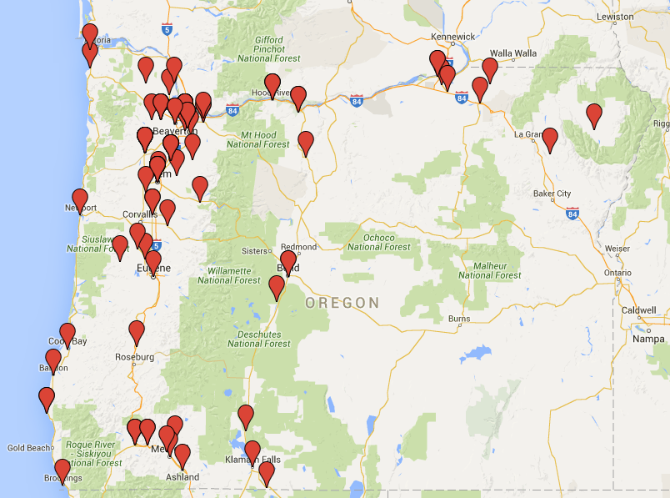
By the Numbers
Grant Awards
Total Grant Awards | $311,436.83
Total Schools Served | 109
Total Teams Funded | 184
FIRST Lego League (FLL) Teams (Elementary and Middle School) | 77
FIRST Tech Challenge (FTC) Teams (Middle and High School) | 77
FIRST Robotics Competition(FRC) Teams (High School) | 30
Number of new teams funded | 77
Percent applications funded | 62%
Percent Schools That Intend to Continue | 94%

- Approximately half of the total funds available for the biennium were awarded to schools in the 2013-2014 academic year. The remaining funds were awarded on a competitive basis for the 2014-2015 academic year.
- The greatest growth in FIRST programs under the FIRST Robotics Grant happened in First LEGO League (FLL), which increased by 60% over the previous year. The growth in FLL (an early years program) could lead to later growth in FTC and FRC. FRC programs have had a slow growth, likely due in large part to a slow economy, which translates to fewer private dollars to fund the more expensive programs – like FRC – and fewer teachers to act as coaches. We also see growing competition from other robotics programs, like VEX and an underwater robotics program sponsored by Hatfield Marine Science Center. With more variety, schools have an opportunity to find what works for them.
- Even with the increase in funding over the previous biennium, only 62% of the applications could be funded.

Student Participation
Total Students Served | 1809
Male Students | 70%
Female Students | 30%
Minority Students | 35%
Students with Disabilities | 5%
Students with Limited English Proficiency | 6%
Students in Poverty | 37%
Students new to FIRST Programs | 74%
High School Seniors Planning to Pursue Further STEM Education | 183

- The student participation statistics reflect only those in programs funded through this grant. Many of the FIRST programs are run after school hours. Some are run as a class or instructional activity during the school day.
- The percent of minority participation in grant-funded FIRST programs rose to 35% in 2014-15, an increase of 9% over the previous year. The grant awards for the 2015-2016 school year will continue to focus on minority participation.
- The percentage of program participants who are female has increased from 24% last year to 30% in 2014-15; the current level has surpassed the percentage of women in the STEM workforce nationally (24%). Strengthening female participation will continue to be a focus of this grant.

Community Participation
Adult Mentors | 569
Sponsors other than this grant | 616
Financial Support other than this grant | $455,553

- These numbers and stories we have collected from FIRST teams demonstrate the positive support that local communities provide for FIRST teams. Most of the adult mentors on FIRST teams are volunteers. On average, the ratio of mentors to students is approximately 1:3. There is a great deal of research that demonstrates the impact of adult mentorship on student success.
- The financial contribution that communities make to support these teams is greater than the grant support provided. This does not include the millions of dollars in support at the state and national level.

Use of Funds
Average Grant Investment per Student | $178.00
How Grant Funds Were Used
Registration | 35%
Coach Stipends | 8%
Purchased Services | 3%
Travel, Food, Lodging | 9%
FLL and FTC Kits | 16%
Materials | 18%
Equipment | 11%

- The greatest use of grant funds (51%) was for expenses related to starting a robotics program for the year. Those expenses included registration of the team and purchase of required kits. Additional materials and equipment needed to design and build a robot amounted to approximately 29% of grant funds. The low percentage used for coach stipends is consistent with the high level of involvement from community volunteers. Finally, travel to events consumed a relatively small percentage of the funds, even though those costs can be very high for teams in many parts of the state.

Comments from the Field
The grant recipients were asked to respond to six questions to provide some understanding on the impact the FIRST Robotics Grant program has had on students, schools, and communities. What follows are examples of feedback received by the grant recipients.

Student Confidence and Engagement
The reports included numerous references on how the FIRST program helped build student confidence in their own abilities and engagement in school and the program. The repeated message was that students were able to connect with others who had similar interests and forge strong team bonds. These are results that are difficult to measure but which can have a profound impact on student success in school.
“The students who participated in the FLL program have become more confident in their own abilities to problem solve and experiment with different ideas. They have developed team working skills that enable them to listen to each other’s ideas and try them out or refine the ideas. They have begun to look at problems, analyze the situation, and look for solutions. FLL has helped the students become more confident in their own and each other’s abilities.” – Brookwood Elementary
“Learning programming, engineering and design, and basic construction skills really gave the team members confidence to tackle new projects in areas other than robotics.” – Driftwood School
“Students gave up their recess to program and build robots. Because of the high interest of the fourth and fifth graders, the third graders have become very interested and now on a typical lunch recess there are 15 children programming, or building robots.” – South Shore Elementary
“The FIRST program is an incredible experience for all those involved. Kids learn more than just engineering and programming. They learn how to think, work as a team, present themselves and be graciously professional. It is the best way to gear our schooling to support kids to pursue the highest demand fields, which are the STEM careers.” – Stanfield Secondary School
“I loved seeing students learn new skills from a mentor or another student, and then watching them use those skills – anything from using a tool, to using CAD software, to learning how to read a blueprint. It was also wonderful to see our students gel as a team. Our team has a number of students on the autism spectrum, and it can be hard for those students to find a place at school where they fit in socially. The FRC team was a place where these students found others with their same interests, and where they were embraced despite of (or even because of) their differences.” – Grant High School

Student Initiative
Building confidence can result in students taking personal initiative on new projects or taking on leadership roles. This may help their team or school as well as themselves, as they build a stronger foundation for career readiness.
“Kids who were shy now spend time doing outreach, kids who had low self-esteem have now taken on roles of leadership, and kids who lacked confidence in science have now found an area where they can explore and grow through project-based learning.”— EagleRidge High School/Ponderosa Middle School
“One student in his second year ‘finally’ learned what it meant to be responsible to his team, and to ‘complete’ a project. Although always enthusiastic, he was easily distracted and rarely worked on anything longer than a few hours before going on to something else. In his first year, he never finished anything. This year, he became ‘responsible’ for the team’s experimental robot – the machine the team used to learn/develop software. The same student took the lead in a post-season project to create a soccer-playing robot. The student aspires to be team captain next season, and seems to have the support of his teammates.” – Benson Polytechnic High School
“Students in our program had an opportunity to demonstrate their robots to all younger grades at our school this year and the ‘buzz’ about our program has increased exponentially this year, particularly in those younger grades. First and Second grade students can’t wait to be in middle school so they can join the robotics club.” – Monroe Grade School
“The younger students on the team are excited to continue their STEM education. Many are already enrolled in the pre-engineering class at the high school, but now there is a sparked interest in the metals/manufacturing program, as the students realize they can help bring their designs to life faster if they possess skills such as machining, welding, etc. One of the three females in the program is so excited, she plans to start working with the metals teacher at the high school over the summer to refine her metal-working skills so she can start in the Advanced Metals class next year.” – St. Helens High School

Community Engagement
FIRST programs depend on community engagement. This ranges from parent support for team activities to volunteer mentors helping team members solve technical problems. More than 500 adults worked with the teams funded with this grant. These adult interactions can lead to positive influences on students’ decisions about education and careers.
“I have been able to recruit some amazing mentors simply by showing off the robot, and the students get so excited to share their experience that it is infectious.” – Scappoose High School/Peterson Elementary

“Eight FRC parents travelled to the FIRST Championship with Team 4488 Shockwave and thoroughly enjoyed the camaraderie among adults as well as seeing their children so happy with the competition and team activities. Several mentors have remarked that they enjoy learning new technologies and applications along with the students in the course of design and fabrication of the robots.” – Glencoe High School/McKinney Elementary
“We began concerted outreach to other schools and FTC teams in our valley. We also began volunteering for civic projects around Ashland. We have raised the profile of STEM education through robotics as we have raised the profile of our team.” – Ashland High School
“Teams invited and interviewed a community mentor to learn about 3-D printing as part of the project. He brought a 3-D printer to the school and demonstrated its use to the kids. They were able to use the product in their project presentation.” – Bridger K-8
“I think the most positive experience I had this year was recruiting my technology teacher (a retired high school tech/chemistry/physics teacher) to come help the team during the build season. He connected with the kids and provided lots of insight and experience to the team. He is now on the school board, and will be a champion for STEM education in our district.” – St. Helens High School
“FTC and FRC teams receive frequent requests to exhibit at assemblies and community events. These public appearances bring students of all ages into contact with applied STEM learning and motivate them to get involved.” – Glencoe High School/McKinney Elementary

STEM Workforce
FIRST programs have an impact on career decisions students make. In some cases these programs provide reinforcement for students who were already considering Science, Technology, Engineering, and Math (STEM). In other cases, they are the stimulus to consider a STEM career.
“The program absolutely builds excitement about STEM, deepens the students' knowledge of topics and ideas in STEM, and exposes them to careers in STEM that they didn't even know existed.” – Grant High School
“A graduating senior on the team is enrolled at OIT and plans to start in the Electrical Engineering program this fall. He is a gifted student and is class valedictorian, but the experiences he had in FTC and FRC helped lead him to his decision to pursue an engineering degree.” – St. Helens High School
“Our senior and lead fabricator and mechanic was accepted at competitive mechanical engineering schools, and received a $12,000 FIRST Robotics scholarship as well as a generous school scholarship. A year ago, he had a little interest in robotics and engineering.” – Summit High School
“I survey students at the beginning and end of each school year and the number of students interested in STEM careers has increased significantly since the start of FIRST programs at our school.” – Monroe Grade School
“The students have been exposed to very important STEM skills that have inspired them to pursue careers in engineering, math, and computer science. All six graduating seniors on our FRC team have been accepted to colleges in computer science and engineering programs.” – Westview High School
“We have had several team alumni attend college and graduate in STEM fields. A number of these students originally expressed little interest or belief in their ability to attend college. This program gave them self-confidence to pursue their interests.” – Lebanon High School

# # #

