Template
Developing a NSLP Food Safety Program

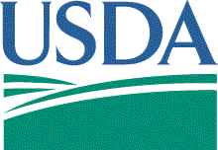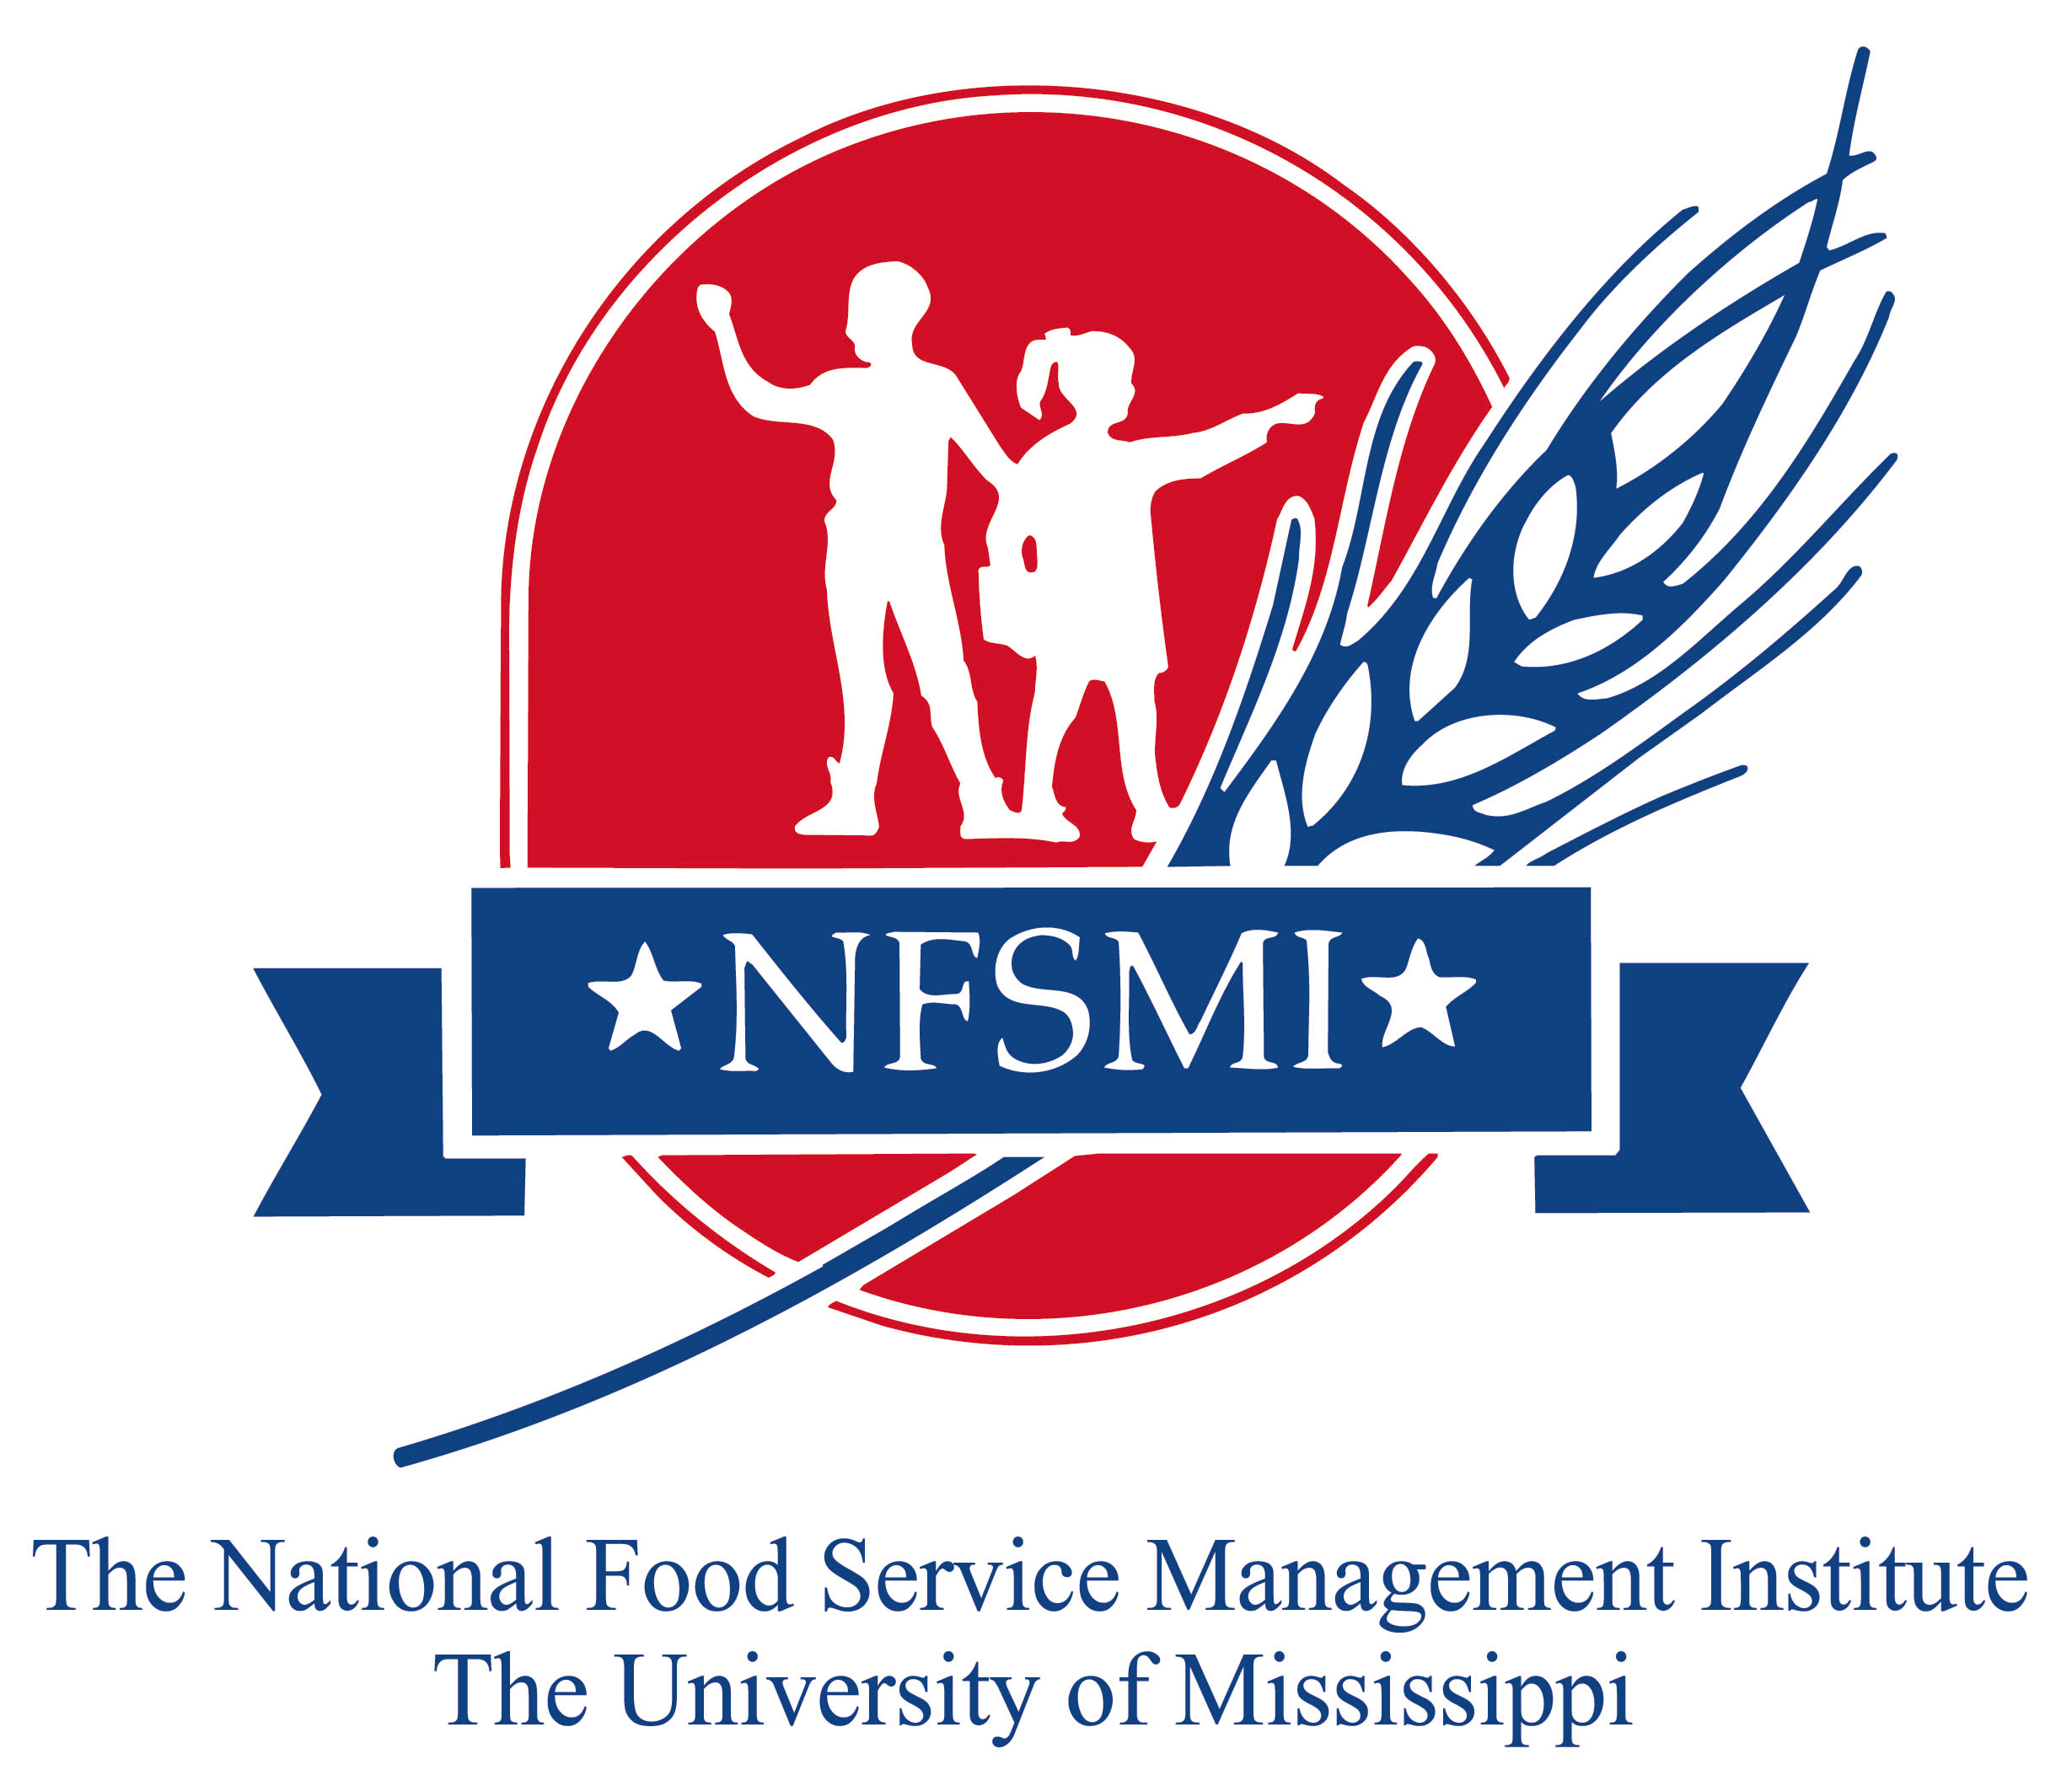

Standard Operating Procedures
http://sop.nfsmi.org/HACCPBasedSOPs.php

The National Food Service Management Institute
The University of Mississippi
ET66-05(PW-Print)

2006

Suggested Reference Citation:
U.S. Department of Agriculture, Food and Nutrition Service, & National Food Service Management Institute. (2006). Developing a school food safety program participant’s workbook. University, MS: Author.

© 2006, National Food Service Management Institute, The University of Mississippi

June 2006

The Developing a School Food Safety Program training materials were written to accompany the U. S. Department of Agriculture’s Guidance for School Food Authorities: Developing a School Food Safety Program Based on the Process Approach to HACCP Principles. The Guidance for School Food Authorities resource is available at http://www.fns.usda.gov. The National Food Service Management Institute developed these materials in cooperation with the USDA Food and Nutrition Service’s Child Nutrition Division and the Food Safety Unit. USDA recommends the Process Approach because it gives you flexibility to create a food safety program specific to your foodservice operation.

The Process Approach was originally developed by the Food and Drug Administration (FDA) for retail food establishments. Follow your State and local public health requirements and your school district policies and procedures.

Food Safety Plan

School: ____________________________________

Site: __________________________________________

This program was developed (Date) _____________________________by
(Name) _________________________________ (Title) ____________________________, The program follows the USDA guidance on developing a food safety program based on the Process Approach. All standards in this plan are based on the
Oregon State Food Code

School Foodservice Staff
Directions: Identify the name of the foodservice staff and their positions.

Name Position
______________________________ ________________________
______________________________ ________________________
______________________________ ________________________
______________________________ ________________________
______________________________ ________________________
______________________________ ________________________
Date_______________________

Menu Items

Directions: Identify where your recipes and monthly menus will be located and the length of time they will be kept on file.

Recipes in the foodservice office are located _______________ (Where) and will be kept on file for _______________________.

Monthly menus are located ________________ and will be kept on file for _____________.

Categorize Menu Items According to
Food Preparation Processes

The Process Approach

The (Name of School) ________________________________ will assign each menu item using Process #1 – No Cook Preparation Process Worksheet, Process #2 – Same Day Service Preparation Process Worksheet, and Process #3—Complex Food Preparation Process Worksheet. The Worksheets will be posted (Location) ______________________________ and a copy will be kept on file (Location) ________________________________. Changes to the menu items will be reflected in the worksheet on a continuous basis.

All foodservice personnel, including permanent and substitute employees, will be given an overview of the Process Approach. Periodic refresher training for employees will be provided (Frequency) ______________.

An easily accessible copy of an explanation of the Process Approach taken from the USDA Guidance document will be available (Location) _________________.

Potentially Hazardous Foods are defined as:
Beef, Pork, Chicken, Turkey, Fish, Eggs, Fresh Dairy, Melons

Process #1  No Cook
Keep food at or below 41 ˚F Degrees.

Menu Item | Recipe Number | Controlling Hazards for Process #1
Temperature
controls:
- Cold holding

SOPs:
- Personal hygiene

- Washing fresh fruits and vegetables

- Limiting time in the temperature danger zone

- Verifying receiving temperatures of food

- Date marking of ready-to-eat food

Process #2  Same Day Service
Cook to correct temperature. Hold and serve at 140 ˚F or above.

Menu Item | Recipe  Number | Temperature | Controlling Hazards for Process #2
Menu Item | Recipe  Number | Cooking | Temperature  controls:  - Cooking  - Hot holding  SOPs:  - Personal hygiene  - Limiting time in the temperature danger zone  - Verifying receiving temperatures of food  - Proper storage of food

Process #3  Complex Food Preparation
Limit time in the Danger Zone (41 ˚F – 140 ˚F)

Menu Item | Recipe  Number | Temperature |  |  | Controlling Hazards for Process #3
Menu Item | Recipe  Number | Cooking | Cooling | Reheating | Temperature  controls:  - Cooking  - Cooling  - Hot holding  - Reheating, if applicable  - Cold holding  SOPs:  - Personal hygiene  - Limiting time in the temperature danger zone  - Verifying receiving temperatures of food  - Proper storage of food

Standard Operating Procedures (SOPs)

The (Name of RCCI) ________________________________ food safety SOPs are checked below. Employees will be trained to follow all applicable food safety SOPs. A complete set of the food safety SOPs will be attached to this food safety program.

Facility-Wide SOPs

_____Cleaning and Sanitizing Food Contact Surfaces
_____Controlling Time and Temperature During Preparation
_____Date Marking and Ready-to-Eat, Potentially Hazardous Food
_____Employee Health Policy
_____Handling a Food Recall
_____Personal Hygiene
_____Preventing Contamination at Food Bars
_____Preventing Cross-Contamination During Storage and Preparation
_____Receiving Deliveries
_____Serving Food
_____Storing and Using Poisonous or Toxic Chemicals
_____Using and Calibrating Thermometers
_____Using Suitable Utensils When Handling Ready-to-Eat Foods
_____Using Time Alone as a Public Health Control to Limit Bacteria Growth in _____Potentially Hazardous Foods
_____Washing Fruits and Vegetables

Specific SOPs to the Food Preparation Process
_____Cooking Potentially Hazardous Foods
_____Cooling Potentially Hazardous Foods
_____Holding Hot and Cold Potentially Hazardous Foods
_____Reheating Potentially Hazardous Foods
_____Preventing Cross-Contamination During Storage and Preparation
_____Transporting Food to Remote Sites (Satellite Kitchens)

Monitoring

Correcting Problems
The foodservice manager at each site will be responsible for ensuring assigned foodservice staff are properly controlling hazards at the required frequency and are documenting required records.
The manager will also be responsible for monitoring the overall performance of standard operating procedures. (Specific details regarding monitoring are addressed in each SOP.)
Monitoring will be a constant consideration. However, the manager will use the Food Safety Checklist to formally monitor foodservice staff (Frequency) ______________. The checklist form is included in this food safety plan.
Foodservice staff is responsible for controlling hazards during food preparation as well as the practices and procedures defined in the standard operating procedures (SOPs).

The (Name of School) ________________________________ will be responsible for developing solutions to problems. These solutions will be reviewed and updated
(Frequency) ______________. Foodservice staff will be responsible for documenting problems and solutions during the food preparation processes as well as any actions taken while performing standard operating procedures.
Employees and substitute staff will be trained on a continual basis in making the right decisions and the importance of finding and fixing problems. A list of common solutions to problems will be attached to this food safety plan and also may be included in standard operating procedures.
Correcting Problems

Directions: Indicate the date a problem occurs. Provide a description of the problem and the activities implemented to correct the problem.

Date | Problem | Action Taken

Recordkeeping

All foodservice staff will be held responsible for recordkeeping duties as assigned. Overall, the foodservice manager will be responsible for making sure that critical information is being recorded and that records are filed in the proper place. Employees and substitute staff will be trained on recordkeeping. Recordkeeping procedures are outlined below and also may be included in standard operating procedures.

Recordkeeping Procedure

- All pertinent information on temperatures, times, and actions taken to correct problems will be kept on clip boards in the kitchen for easy use.
- All applicable forms for daily records will be replaced on a weekly basis or sooner, if necessary.
- In the case of weekly records, forms will be replaced on a monthly basis.
- All completed forms will be filed in the manager’s office.
- The foodservice manager is responsible for making sure that all forms are updated, available for use, and filed properly after completion.
- The foodservice manager is also responsible for educating all foodservice personnel on the use and importance of recording critical information.

Recordkeeping

DOCUMENTATION (RECORDS) DOCUMENTATION SCHEDULE
Food Production Records
End Point Cooking Temperature _______________

Time and Temperature for Holding _______________

________________________ _______________

________________________ _______________

Equipment Temperature Records
Receiving Logs _______________

Freezer Log _______________

Cooler Log _______________

Thermometer Calibration _______________

Storage Room Logs _______________

______________________ _______________

Review Records
Food Safety Checklist _______________

Manager’s Checklist _______________

______________________ _______________

______________________ _______________

Training Logs _______________

Correcting Problems Records _______________

Reviewing and Revising the Food Safety Program

The school foodservice manager will review the school food safety program at the beginning of each school year and when any significant changes occur in the operation. The Food Safety Program Review Checklist included in this document will be used for the review.

Source: U. S. Department of Agriculture, Food and Nutrition Service. (June 2005). Guidance for school food authorities: Developing a school foodservice program based on the process approach to HACCP principles.

Food Safety Program Review Checklist

1. Documents to review
___ Standard Operating Procedures
___ Food Preparation Process Charts
___ Control Measures in the Process Approach
___ Correcting Problems

2. Monitoring recordkeeping. Choose at random one week from the previous four weeks.

Type of Record  (SOP, Temperature Log, Correcting Problems, etc.) | Monitoring Frequency and Procedure  (How often? Initialed and dated? Etc.) | Record Location  (Where is record kept?)

Describe the strengths or weaknesses with the current monitoring or recordkeeping methods.

Who is responsible for verifying that the required records are being completed and properly maintained?

Describe the training that has been provided to support the food safety program.

Do the managers and staff demonstrate knowledge of the plan?

Have there been any changes to the menu or operation (new equipment, etc.)?

Was the plan modified because of these changes?

