Salem-Keizer Public Schools, Head Start Program
October 2012

We are going on a field trip to EZ Orchards Farm!
Vamos a ir a una salida de campo a EZ Orchards
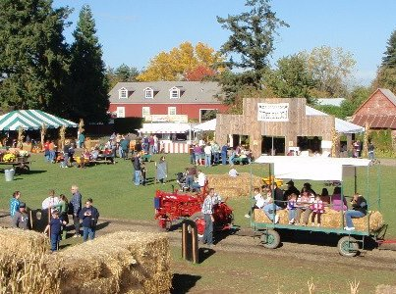

We will ride the bus to the farm.
Vamos a tomar el camion a la farma.
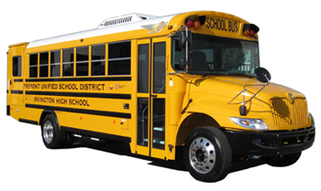

We will go on a hay ride.
Iremos en un paseo de paja.

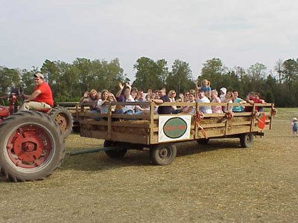

We will pick a pumpkin.
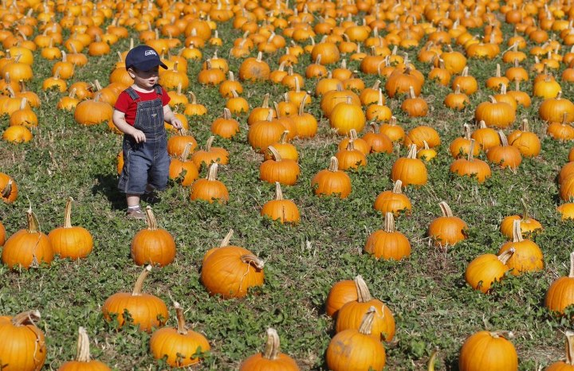
Escojeremos una calabaza.

We will walk through a corn maze.
Caminaremos por un laberinto de maiz.

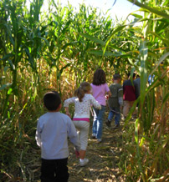

We will pick an apple.

Escojeremos una manzana.

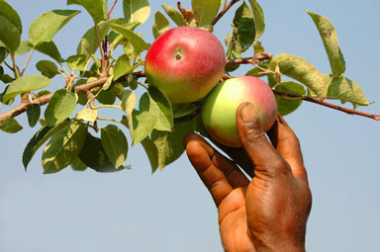

We will eat a doughnut.
Comeremos una dona.

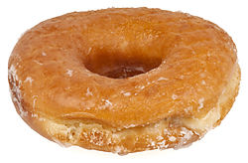

We will eat lunch at the farm.
Comeremos lonche en la granja.


We will ride the bus back to school and then go home.
Tomaremos el camion para regresar a la escuela.

Pumpkin Patch Field Trip
Salida de Campo a la Granja de Calabazas

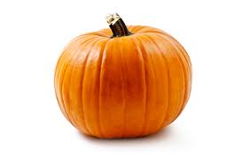

This book is called a “social story”. It is a way to prepare children for an upcoming event or remind them of expectations. The original reason for creating this book was for one of the students in this particular classroom who is autistic. He doesn't handle changes to routine or unfamiliar things very well. I wrote the book for him, but ended up using it for my entire class. Going to the pumpkin patch is unfamiliar to most 3-4 year olds. We used it to talk about what we would be doing on the field trip and what to expect. It also opened up the door for discussion about harvest and where our food comes from - especially with picking an apple off of a tree.

This activity was made possible by funding received from the ODE, CACFP Child Care Wellness Grant 2012.

This event was designed to meet the goal of Key Strategy #1 to Increase the amount and variety of fruit and vegetable consumption for children in care.

"In accordance with Federal law and U.S. Department of Agriculture policy, this institution is prohibited from discrimination on the basis of race, color, national origin, sex, age, or disability. To file a complaint of discrimination, write USDA, Director, Office of Civil Rights, 1400 Independence Avenue, SW, Washington, D.C. 20250-9410 or call, toll free (866) 632-9992 (Voice). TDD users can contact USDA through local relay or the Federal relay at (800) 877-8339 (TDD) or (866)377-8642 (relay voice users). USDA is an equal opportunity provider and employer."

